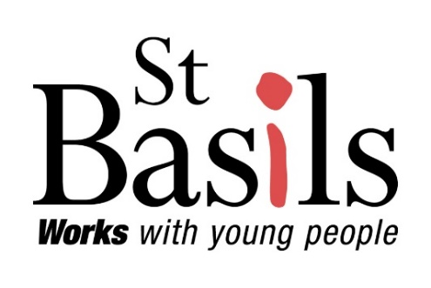
Guidelines are information intended to advise people on how something should be done or what something should be. A guideline is a statement by which to determine a course of action by streamlining processes according to a set routine or sound practice.
Name: | Additional Needs and Adaptation Guidelines
File No: | G16
Version: | 1.0 (Final)

Guideline Custodian: | Director of Housing
Guideline Champion: (if applicable) | Health, Safety & Facilities Manager
The purpose of this document is to provide guidance and understanding of St Basils approach to the provision of aids and adaptations to support our young people with the management of long-term health issues or disability to support them to live in their property.

It will set out the criteria by which St Basils will assess requests for aids and/or adaptations to their properties.

This guidance applies to young people living in St Basils properties, who require additional aids and/or adaptations to live in their home.

This guidance refers to and only applies to those with a disability. Under the terms of this guidance, we have used the definition of disability from the Equalities Act 2010, which states a person is disabled ‘if they have a physical, mental or sensory impairment that has a substantial and long-term (i.e. more than 12 months) adverse effect on your ability to do normal daily activities.’

Definitions
Young People – Tenants or licensees living in properties where St Basils is the Landlord.

1. Introduction
1.1 Housing adaptations can often play an important role in enabling a disabled person to be comfortable and safe in their home, promoting independent living or to use their home more effectively.

1.2 The link between housing and wellbeing is increasingly acknowledged. ‘The right home environment is essential to health and wellbeing for our young people. Accommodation adaptations can improve quality of life, wellbeing, enable safe access and egress and increase independence.

1.3 St Basils will consider applications for adaptations from young people if they meet the eligibility criteria and will look at the best use of resources for reasonable adjustments, or through options to relocate to a more suitable property.

2. Legal & Regulatory Framework
2.1 This document makes reference to the legal requirements and policies that must be adhered to. We have had regard to legislation including (but not limited to) the following:
- Equality Act 2010
- The Housing Act 1996
- Data Protection Act 2018 (UK GDPR)

3. Equality, Diversity and Inclusion (EDI)
3.1 St Basils promotes equality and diversity in all services that we provide. Our aim is to continue to maintain equality and ensure that we adapt our homes in a non-discriminatory way based on meeting housing need. We also anticipate that the transparency of this will not let any customers be treated less favourably on the grounds of gender, marital status, pregnancy and maternity, race, disability, sexual orientation, age, faith or gender reassignment. St Basils will treat all applications for additional needs and adaptations in a sensitive and supportive manner. St Basil’s has carried out an internal Equalities Impact Assessment for this document.

This document can be made available in other languages and in large print or audio transcript if required.

4. Eligibility
4.1 You will be considered for disabled adaptations if you are:
- residing in a property where St Basil’s is the landlord,
- not residing in emergency accommodation
- you have an impairment which has a serious long-term effect on your ability to carry out normal day to day activities.

4.2 If you are living in a property which St Basil’s manages on behalf of another organisation, we will support you to submit an application for adaptations to your landlord.

4.3 Adaptations costing more than £500 in total will require an Assessment of Individual Needs from a social services’ occupational therapist or a hospital occupational therapist.

4.3 The adaptations recommended must be necessary, appropriate and reasonable and practicable to meet the needs of the disabled person.

4.4 Major Adaptations will not be carried out at a property where the young person has an active Housing Application or is actively seeking a home-swap via a mutual exchange.

5. Making an application for aids and/or adaptations

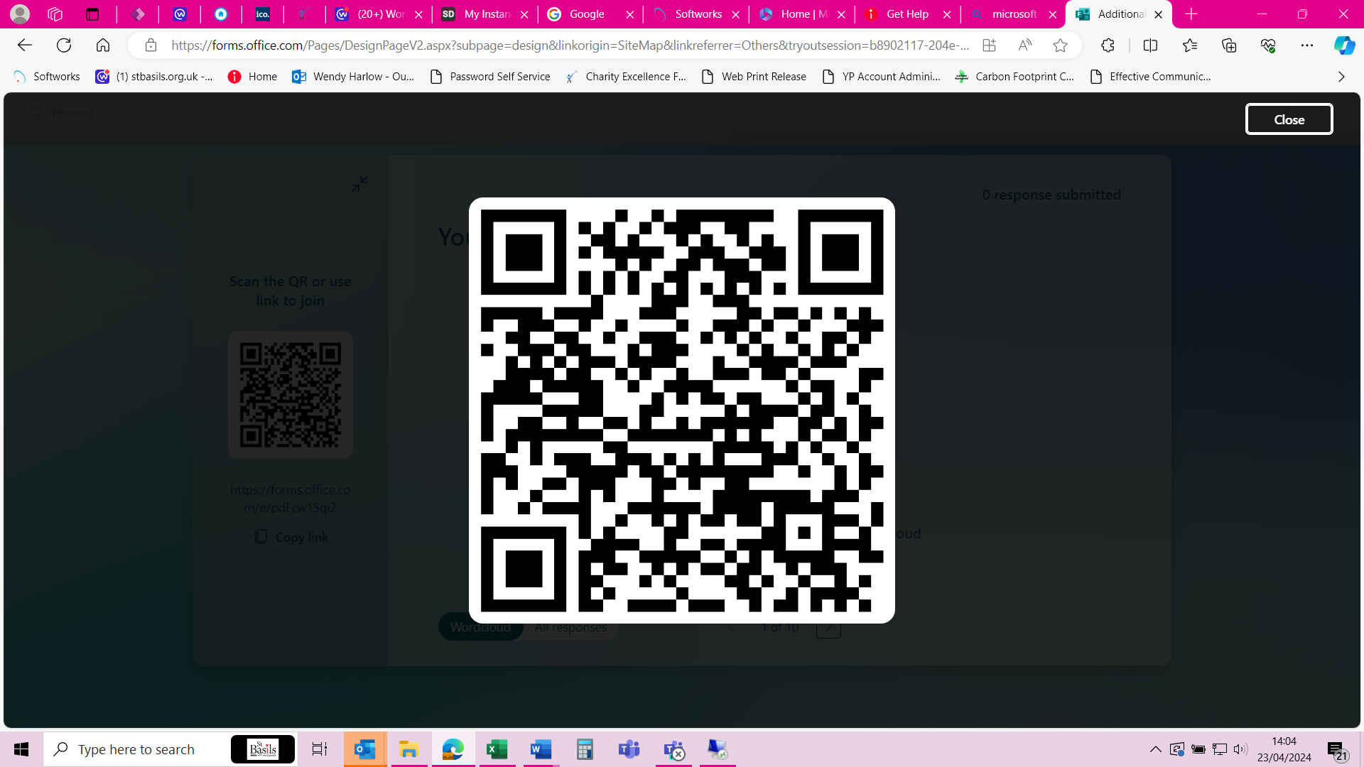
5.1 Young people can contact their Progression Coach (PC) for support to make a request for an aid or adaptation to their property. The Additional Needs and Adaptations Request Form can be found in
appendix 1 of this document.

Alternatively, you can use the link below or the code opposite, which will take you to an online form that can be completed and submitted.

https://forms.office.com/e/pdFcw1Sqi2?origin=lprLink

5.2 St Basils will only consider adaptations after a St Basils surveyor, in conjunction with the Youth Service Manager, has assessed the household and property situation and identified that the works are both necessary and appropriate, given the nature of the disability and the adaptability of the property.

5.3 In all cases, St Basils will ensure:
- Cases are assessed fairly and equally
- Exceptional individual needs are taken into account
- Public money is used responsibly
- Alternative options to meet the applicant’s needs are considered

5.4 The PC will work closely with the Property Services Department in arranging visits where necessary with the Surveyor/Assessor. With complex cases, other persons may need to be involved to discuss all available options for the young person.
5.5 When making a decision on adaptations we will take into account:
- existing adaptations
- the cost of adaptations necessary to make the property suitable
- the adaptability of the current property
- property type and demand
- the likely availability of more appropriate alternative accommodation
- the availability of the young persons existing support network and carers
5.6 St Basils will:
- acknowledge receipt of the request within 5 working days
- assess if the request is reasonable and whether the property is suitable
- notify the young person whether St Basils will or will not undertake to fund and provide the aid/adaptation
- advise the young person as to the extent of the work to be undertaken
- advise the young person of the timescale of the work
- notify the young person which contractors (where applicable) have been instructed to do the work and arrange appointments for the contractors to gain entry
5.7 To qualify for the disabled aid/adaptations the person concerned would have to be a young person or the partner/child of a young person who is known to St Basils and its agreed permanently resides at the address.
5.8 St Basils has the final decision on whether to accept a request and/or the medical professional’s recommendations and ultimately, adapt its properties.

5.9 It is the policy of St Basils to examine all the options available to the individual, especially where it is deemed to be more cost effective.

5.10 As a charity St Basils only has a small Aids and Adaptations budget and therefore demand can exceed the budget available and therefore requests may have to be prioritised which determines their position for works to be carried out in conjunction with the date of assessment.

6. Types of aids and adaptations
6.1 There is a £500 limit applicable to each adaptation, and works can include but are not limited to:

- Grab rails
- Mopstick bannister
- Lever taps
- Overbath showers
- Half steps
- Removal of thresholds
- Installation of specialist lighting
- Installation of flashing doorbells or smoke alarms
- Window opening technology
- Level Access Showers
- Ramps to access the property at the front or back

6.2 St Basils young people must not organise their own adaptations privately.

7. Circumstances in which work will not be carried out
7.1 St Basils at the advice of the Surveyor may deem that it is not reasonable and practicable to adapt the property, for example:
- installing a level access shower to a flat above the ground floor which cannot be accessed by an existing lift.
- Where an adaptation would adversely affect St Basils ability to make best use of the stock and re-let the property in the future.
- Where an adaptation would place others at risk e.g. a stairlift installed in a communal stairway which could impede access for other residents.
- Adaptations for the storage of mobility scooters
- Appliances such as ovens, hobs, fridges unless there is a specific need for a piece of equipment to meet their requirements on a case-by-case basis.
- Excessive cost

Appendix 1 – Additional Needs and Adaptation Request Form (this form can also be accessed via the link or QR code in section 5.1

Young person Name: * |  | Telephone number: *
Address: * |  | Email Address: *
Please let us know what you are struggling with in your home. *
What do you think you need to help you? *
Has a medical professional stated that you need this help? If yes, who? *
Are you happy for us to contact the named medical professional to discuss your required adaptation? *
Your signature: |  | Date:
We will process your personal data in line with the data protection law set out in our privacy notice. You can find our privacy notice on our website.

Comment from YSM:
YSM Signature: |  | Date:
St Basils will acknowledge receipt of your request within 5 working days

Submit this form to feedback@stbasils.org.uk

Appendix 2 – Additional Needs and Adaptation Processing

For office use only:

Young person name: |  | Reference No:
Received by: |  | Date Received:
Does the individual meet eligibility criteria? |  | Is the required help something St Basils can provide?
Has an OT assessment been received? |  | Yes |  | No
Date of surveyor visit:

Name of Surveyor in attendance:

Was YSM in attendance for this visit?

Surveyor notes and comments:

Surveyor assessment as to whether the required help can be achieved? |  | Yes |  | No
Cost of required help? |  | £
Has the help requested been approved or refused? |  | Approved |  | Refused
If refused, give reasons why:

Approval up to £500.00 – Property Services Manager
Approval by: |  | Date:
Approvers comments:

Approval over £500.00 – Director of Housing
Approval by: |  | Date:
Approvers comments:

Additional Notes:

