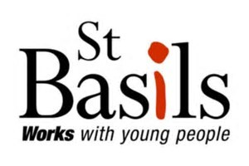

Gender Pay Report
April 2025
(April 2024 data)
St Basils’ Gender Pay Report
All UK employers over a certain size are required to report on their gender pay gap. In this report you’ll find a snapshot of the gender pay balance within St Basils, accompanied by notes to explain what the results mean.
One of St Basils’ strategic priorities is ‘Challenging discrimination and promoting diversity and cohesion through employment, service delivery and community engagement’ – central to which is our ongoing commitment to equality, diversity and inclusion, and to addressing workplace barriers to equality.
We welcome the requirement to report on this data and will use the information to inform our continuing commitment to ensure that everyone – regardless of race, ethnicity or gender – has an equal opportunity to thrive.
The figures in this report relate to pay in the month of April 2024.
What is the gender pay gap?
The Gender pay gap analyses the difference between the average earnings of all male and female employees in an organisation, regardless of their role or seniority. The following information is included:
- mean gender pay gap in hourly pay
- median gender pay gap in hourly pay
- mean bonus gender pay gap
- median bonus gender pay gap
- proportion of men and women receiving a bonus payment
- proportion of men and women in each pay quartile
Gender pay should not be confused with equal pay, which is about ensuring that men and women undertaking work of an equal value are paid a similar amount for that work.
A gender pay gap does not indicate a pay equity issue or an imbalance in St Basils’ pay structures and policies. What the gap does reflect is the current distribution of men and women across the pay quartiles, and whether there is a varying distribution.

St Basils’ Gender Pay Gap Data
Table 1 – Difference in hourly pay rate between men and women
 | % Difference
Mean Hourly Rate | 4.7%
Median Hourly Rate | 0.0%
St Basils mean and median differences between the hourly pay rate of men and women.
Table 2 – Difference in bonus pay between men and women
 | % Difference
Mean Bonus Pay | 0%
Median Bonus Pay | 0%
St Basils does not pay any bonuses which qualify for reporting purposes.

Table 3 – Proportions of men and women staff paid bonus pay
 | % Difference
Mean Bonus Pay | 0%
Median Bonus Pay | 0%
As above

Table 4 – Proportions of men and women staff in pay quartile bands
Quartile | Men | Women
Upper Quartile (A) | 35% | 65%
Upper Middle Quartile (B) | 21% | 79%
Lower Middle Quartile (C) | 14% | 86%
Lower Quartile (D) | 32% | 68%
Overall | 25% | 75%

Table 4 illustrates the proportion of men and women in the quartile bands and shows that St Basils has a significantly higher proportion of women in all quartiles. However, the highest % of women are in the Lower Middle Quartile whereas this quartile contains the smallest % of men. This quartile is where most frontline workers would fall, which make up the largest proportion of St Basils’ workforce, and are mostly worked by women at St Basils. This explains why there is a small pay gap at St Basils.

Continuing Actions
In our Equality, Diversity and Inclusion Policy and Action Plan, we are committed to ensuring that we continue to reflect the communities we serve at all levels within St Basils and take steps which address systemic inequities to achieve fairness and inclusion. This includes making sure that the St Basils’ workforce, especially those in frontline roles, has a more equal representation of men, who currently make up only 25% of St Basils’ workforce. Having a more balanced workforce with regards to gender is especially important for St Basils as approx. 59% of the young people who approach us for assistance are male. Encouraging more men to apply for roles at St Basils, particularly in frontline Progression and Housing Management roles, is one of our EDI priorities for the year ahead.

Written Statement
I confirm that the published information is accurate,

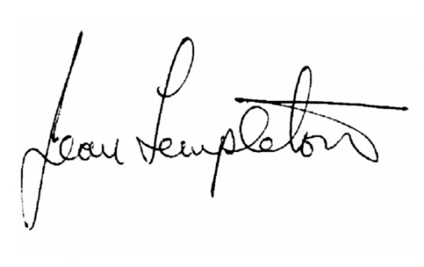
Jean Templeton
Chief Executive Officer

Annex 1 - Year on Year Comparisons

Headline Figures
% Difference | 2017 | 2018 | 2019 | 2020 | 2021 | 2022 | 2023 | 2024
Mean Hourly Rate | 3.8% | 0.8% | 5.8% | 6.3% | 5.8% | 3.7% | 4.9% | 4.7%
Median Hourly Rate | 0.9% | 3.1% | 3.1% | 3.6% | 2.0% | 0.0% | -1.4% | 0.0%

St Basils’ mean hourly rate % difference decreased slightly in 2024 compared to 2023. This can be attributed to more women taking on management roles (falling into the Upper Middle Quartile) and a small increase in men occupying roles at the Real living Wage level (falling into the Lower Quartile) compared to the previous year.
The median hourly rate difference has gone back to 0% in 2024, which is due to there being more women in the two middle quartiles than the other two quartiles, combined with the more uneven spread of men across each quartile.
Quartile Analysis
 | Men |  |  |  |  |  | Women
 | 2019 | 2020 | 2021 | 2022 | 2023 | 2024 | 2019 | 2020 | 2021 | 2022 | 2023 | 2024
Upper Quartile (A) | 37% | 35% | 36% | 29% | 34% | 35% | 63% | 65% | 64% | 71% | 66% | 65%
Upper Middle Quartile (B) | 30% | 29% | 25% | 25% | 26% | 21% | 70% | 71% | 75% | 75% | 74% | 79%
Lower Middle Quartile (C) | 24% | 23% | 25% | 25% | 19% | 14% | 76% | 77% | 75% | 75% | 81% | 86%
Lower Quartile (D) | 17% | 18% | 27% | 32% | 31% | 32% | 83% | 82% | 73% | 68% | 69% | 68%
Total | 27% | 26% | 28% | 28% | 27% | 25% | 73% | 74% | 72% | 72% | 73% | 75%

The relatively small number of staff employed by St Basils (324 in April 2024 data) means that small movements in staff numbers can result in noticeable movements in both the mean and median pay gap.
The main reason for the existence of a pay gap at St Basils continues to be the low number of men employed in front line support work.
Benchmarks in this area are problematic due to the difference in full time and part time data, sector type and organisation size. It is however noted that for 2024, housing providers and similar charities of a similar size to St Basils (however a mixture of non-profit and for-profit providers) showed on average a mean hourly rate gap of 4.8% and a median hourly rate gap of 3.2% [16 organisations, GOV.uk data].

