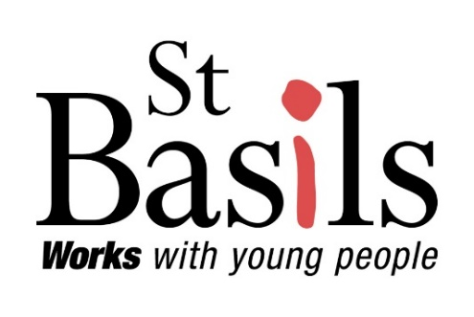
Policy Name: | Engagement Policy and Procedure
File No: | P32
Version: | 4.0 (Final)

Policy Custodian: |  | Youth Engagement Manager
Policy Champion: (if applicable) |  | N/A

This document also relates to the following St Basils policies, procedures and guidelines:

- Equality, Diversity & Inclusion
- Allocations and Referrals
- Assessment and Support planning
- Company Membership
- Comments, Compliment and Complaints
- Health and Safety
- Lettable Standards
- Recruitment and Selection
- Youth Standards

Consultation Framework:
Consultation of this policy has taken place with the following parties during the following periods of time:
Custodian |  | 19.05.2025 – 22.07.2025
Champion |  | N/A
Managers |  | 08.06.2025
Youth Advisory Board |  | 10.06.2025 Approved
Senior Leadership Team |  | 19.06.2025 Referred 17.07.20258 Approved
Committee (SDDC) |  | 04.08.2025 Approved
Approved by: | Service Delivery and Development Committee |  | Issue date: | 13.08.2025
Approved date: | 4th August 2025 |  | Review due by: | August 2028

Contents
Policy Statement 3
Scope of Policy 3
Definitions 3
Legislation and Guidance 4
General Principles 4
Roles and Responsibilities 7
Equality, Diversity and Inclusion 7
Training Requirements 7
Communication 7
Responsibility 7
Continuous Renewal Clause 7
Disclaimer 8
Appendix 1 - Consumer standards 1 April 2024 9
Appendix 2 – The Supported Accommodation Regulation 2023 (Regulation 7) 10

Policy Statement
One of St Basils’ key principles is ‘Young people first’, this defines all we do. One of our strategic priorities is young people fully involved in setting standards, identifying priorities and monitoring services. We are passionate about working with young people; our aim is to promote open, accessible and supportive environments throughout the organisation and on a national basis where young people can meaningfully have their voices heard to make change happen. At St Basils we believe young people should have the opportunity to engage Locally, Regionally and Nationally, leading the way by consulting, advising and influencing a wide variety of organisations, local authorities and government departments on their policy development and implementation from a youth led perspective.

Youth Voice at St Basils works on Local, Regional and National levels and is made up of young people aged 16-25 years who have experienced homelessness, sharing their lived experiences to support and bring about change. The more, young people can be engaged in making decisions about their own lives, their environments, and their communities, the more likely they are to successfully move onto independence.

Using St Basils Psychologically Informed Environment programme we actively promote opportunities and create supportive environments to ensure young people feel able to engage at all levels throughout the organisation. Through our opportunities for engagement, we will respond to the voices of young people and St Basils will continue to grow and respond to the ever-changing challenges facing young people.

St Basils will ensure as an agency we are forward thinking, responsive and flexible to the changing needs of young people and their environment and will seek out the best forms of engagement to make change happen and ensure our services meet the needs of young people in an ever-changing environment.

In our approach of working with young people, we challenge divisive perceptions of ‘them and us’; a partnership model enhances everyone’s contribution.
St Basils believes that the unique experiences, insights, and skills, held by young people are inherently important assets which must be instrumental in shaping the organisation’s strategy, policy and practice.
Through young people’s authentic engagement in the running of St Basils, our services are crafted to provide the best outcomes for both young people and the communities they are part of.

The following beliefs about engagement and working with young people underpin all of our work:
- The more young people that can be engaged in making decisions about their own lives, their environment, and their communities, the more likely they are to successfully move into independence.
- When young people have tangible evidence that they can succeed and change their own world for the better, they make rapid progress on their journey.
- The more that young people can contribute to the running of St Basils, the more effective and relevant we will become, and the more young people will see that they can influence the world around them.
- Positive social networks reduce the risk of further exclusion, increase the range of resources and skills available to a young person, and help to smooth out the up and downs of growing up.
This policy outlines how our commitment to engaging young people in all aspects of the organisation will be realised.

Scope of Policy
This policy applies to all employees in all departments and services as well as young people whether they are St Basils’ residents and/or support service users or not.
For the purposes of this policy the term ‘employee’ will include all employees (whether full time or part time), casual workers, contracted workers and volunteers.

This policy and procedure do not form part of an individual employees’ contract of employment

Definitions
In our practice we commonly use the term engagement, rather than involvement. Through the term engagement we address our obligations to involve young people, but go beyond this to offer wider opportunities, to grow young peoples’ confidence, aspirations, skills, and to affirm their value and voices.

Legislation and Guidance
Data Protection Act 2018 (GDPR)
Equality Act 2010
Supported Housing (Regulatory Oversight) Act 2023
Social Housing Regulation Act 2023
As a housing association, St Basils is subject to and comply with the Regulator of Social Housing - Transparency, Accountability & Influence Standard. (see appendix 1)
We also comply with the Social Care Common Inspection Framework; and
The Supported Accommodation Regulation 2023 (see appendix 2)

As a registered provider of housing and support services, St Basils is also subject to local government quality frameworks, where the term involvement is also used with the similar requirements. Other funders and partners require St Basils to consult and involve our young people in our service development.

General Principles
St Basils is committed to facilitating young people’s engagement in the development of its strategic direction and services, this may be demonstrated through the 12 standards for all St Basils employees and services, developed by St Basils young people. These are:

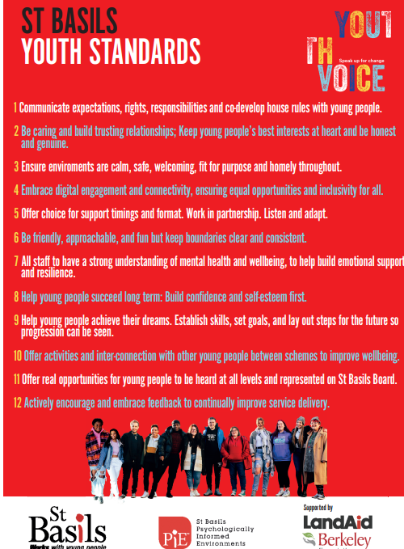

These standards have been developed by young people and hold St Basils accountable to how we work and respond to our young people.
At St Basils we believe that engagement is more than opportunities for just voices to be heard – but more as an opportunity for young people to shape and develop all services / areas of our business, which makes St Basils unique – the standards that young people have developed ensures that young people are at the forefront of our organisation and the essence of true engagement.

St Basils will ensure employees take an active role in promoting and facilitating young people’s engagement throughout the organisation and embed these standards through all areas of our work. Our
governance structure is open, accessible, and supportive of young people’s involvement and contributions. Our Youth Advisory Board enables open dialogue between young people, Management, Directorate, and our main Board.

St Basils provides two places on St Basils Board of Directors to ensure there is a current youth perspective in effective governance management. St Basils Youth Advisory Board offers a diverse youth perspective on all areas of our work contributing ideas that inspire St Basils to implement new ways of working which meet the ever-changing needs of our young people.

At St Basils we believe that engagement is an essential part of young people’s journey into education, employment and training by providing access to the Employability Team who provide a specialist service and support our young people in their desired aspirations.

St Basils will support its young people to have influence and comply with the Regulator of Social Housing standard through:

Local Engagement (Service based)

Support Work- encouraging young people to work in partnership with Progression Coaches to develop an individual plan as part of the support planning process, to ensure that the young people successfully move on to independent living. As per the Supported Accommodation Regulation 2023 (Regulation 7) we will ensure that young people are encouraged and enabled to take a lead role in determining the support they receive and to participate in, and influence how the supported accommodation operates.

Young Peoples Surveys - All young people in St Basil’s accommodation are required to complete bi-annual young people’s satisfaction survey.

St Basils collect and report on a suite of performance / satisfaction measures called the Tenant Satisfaction Measures (TSMs). The TSMs comprise of 10 landlord reported measures, based on our performance information at the end of the financial year and 12 tenant perception measures, which we obtain through a survey with a sample of our tenants to find out what they think about the services we provide to them.
The annual survey results are published, so our young people can see how we are performing and hold us to account.
St Basils analyse the survey responses given by the young people and we feedback our response in a ‘You said, We did’ style – captured within the ‘Time2Talk’ sessions.

Time 2 Talk Sessions Supporting young people to run and take ownership of residents’/ service users’ meetings that aim to have a significant influence on how services are run locally. These sessions are run as a minimum on a monthly basis.

House Reps- House Reps are nominated by their peers within the housing project they live in, representing the views and opinions of the residents and sharing these with staff teams. The House rep holds minimal monthly meetings to discuss matters within their project.

Let’s Engage Fund St Basils provides funding opportunities for young people to connect through creative engaging in activity-based projects to promote connection with their peers and develop confidence and self-esteem.

Complaints, Comments & Compliments - Young people can make a comment, compliment or formal complaint. Complaints posters and leaflets are available in all our services. As per the Supported Accommodation Regulation 2023, we will ensure young people know how to make a complaint or representations in relation to the support and accommodation provided and how any such complaint will be dealt with.

Volunteering & Fundraising - Young people can volunteer at St Basils or get involved in many of our fundraising events.

Youth Voice (Organisation wide)
Youth Advisory Board (YAB) – 15 young people, meeting virtually once a month, representing all regional areas in which St Basils operates. They provide a youth perspective of our work and monitoring the 12 Youth Standards.

Young people’s Engagement in Staff Recruitment Young people are trained to be involved in a youth- led interview panel interviewing prospective St Basil’s employees who will be working directly with young people.

Co-opted Directors - Members or former members of the Youth Advisory Board will have the opportunity to be interviewed and recruited onto St Basils Board of Directors as Co-opted Directors. This is to ensure there is a youth perspective on the Board. The Board is responsible for monitoring the strategic direction of St Basils, ensuring that St Basils objectives are met and the service is being delivered effectively.

Members of the YAB will have the opportunity to meet with Directors including the Chair of the Board to highlight areas relevant for strategic development. Directors will visit projects and may speak to groups of staff and young people about their experiences. The Youth Standards are at the forefront of these visits, Directors will be able to see for themselves how they are put into practice within projects.

Youth Voice National - National opportunities for young people across England to consult, advise and influence a wide variety of organisations, local authorities and government departments and research

Youth Ambassador Volunteer
The Youth Ambassador programme offers opportunities for young people that have been involved in YAB to take on a volunteer role to support and enhance the current Youth Engagement Offer and mentor and support their peers and support the development of service delivery and design.

Youth Engagement Power App
Youth Engagement interactions are logged across St Basils and are monitored on a monthly basis and presented to St Basils Senior Leadership Team to ensure there is a consistent offer across St Basils.

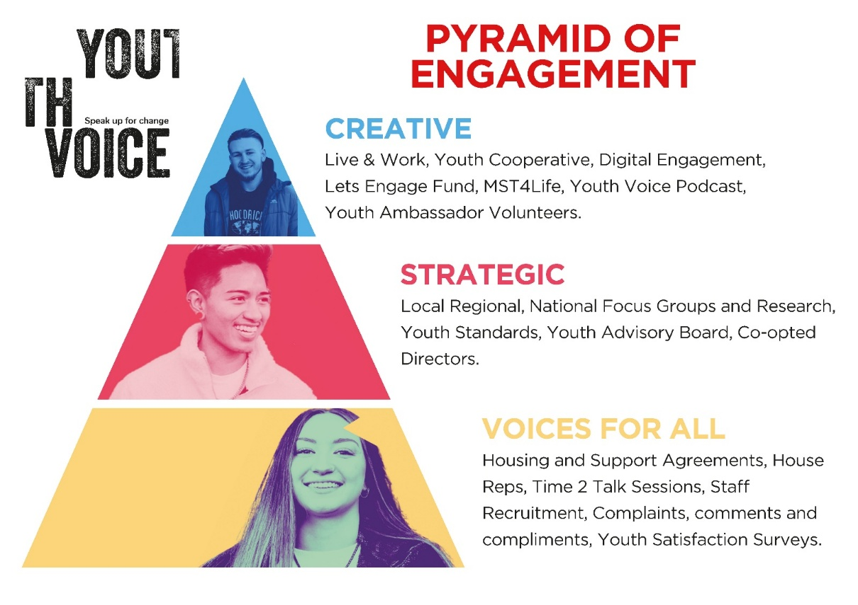

Roles and Responsibilities
Young people will contribute to the continued development of St Basils’ Engagement Strategy by taking part in reviews of the effectiveness and development of this policy.

All St Basils employees who work directly with young people will play a key role in implementing this policy by ensuring they identify, encourage and support opportunities for engagement internally and externally.

It is the responsibility of all employees to ensure that young people are aware of all the opportunities to engage throughout St Basils and support them with any specialist requirements such as language, communication or cultural requirements in order to do this.

Equality, Diversity and Inclusion
At St Basils, we believe that every young person has a voice that deserves to be heard. We are committed to creating a youth engagement environment that is inclusive, representative, and empowering for all.
We actively seek out and embrace diversity in all its forms—race, ethnicity, gender identity, sexual orientation, disability, faith, socio-economic background, and lived experience—because we know that true inclusion means everyone feels seen, valued, and respected.
We understand that “If you can’t see it, you can’t be it.” That’s why we are intentional about ensuring that the young people who shape and influence our work reflect the rich diversity of the communities we serve. We want every young person to know you belong here, your voice matters, and your perspective is powerful.
Inclusion is not just a value—it’s a vital part of how we work. We are committed to removing barriers, challenging inequality, and creating safe, welcoming spaces where all young people can thrive and lead.
We recognise the importance of adapting our engagement approaches to meet the needs of all young people, including those who are neurodiverse or for whom English is not their first language. We are committed to using accessible communication, flexible participation methods, and culturally sensitive practices to ensure everyone can fully engage and contribute.
Together, we are building a future where every young person can see themselves in the decisions that affect their lives.

Training Requirements
St Basils will ensure that all staff, volunteers and young people have the required training to fulfil the roles specified in this policy to ensure effective engagement is maintained and as part of their continued development

Communication
This policy will be communicated effectively to all employees via a range of different media avenues and can be produced in other formats where needed.

Responsibility
The Youth Engagement Manager is responsible for ensuring this policy is implemented and monitored.

The implementation of this policy and the Youth Standards will be monitored through internal and external reviews and KPIs. The review process will help inform the future strategic direction of Youth Engagement at St Basils and will identify priorities for action. This will ensure there is effective and consistent monitoring of engagement across the organisation.

Continuous Renewal Clause
This procedure will be reviewed every 3 years by the organisation to ensure it is in accordance with good practice guidance, prevailing legislation and statutory frameworks. However, this policy may be assessed before that time as necessary – such as:
- if it becomes ineffective
- to reflect substantial changes in practice
- following inspection, as recommended by auditors
- or changes required by law

Disclaimer
This document can only be considered valid when viewed on the St Basils Intranet/Shared: Drive. If this document has been printed or saved to another location, you must check that the version number on your copy matches that of the document online. Hard copies of this document are considered uncontrolled - please refer to the St Basils intranet for latest version.

Appendix 1 - Consumer standards 1 April 2024
Transparency, Influence and Accountability Standard
The link to the standards can be found below
April_2024_-_Transparency__Influence_and_Accountability_Standard_FINAL__1_.pdf

Specifically in relation to required outcome:

  - Engagement with tenants 1.3.1 Registered providers must take tenants’ views into account in their decision making about how landlord services are delivered and communicate how tenants’ views have been considered.
2.2 Engagement with tenants
2.2.1 Registered providers must give tenants a wide range of meaningful opportunities to influence and scrutinise their landlord’s strategies, policies and services. This includes in relation to the neighbourhood where applicable.
2.2.2 Registered providers must assist tenants who wish to implement tenant-led activities to influence and scrutinise their landlord’s strategies, policies and services. This includes in relation to the neighbourhood where applicable.
2.2.3 Registered providers must provide accessible support that meets the diverse needs of tenants so they can engage with the opportunities in 2.2.1 and 2.2.2.
2.2.4 Registered providers must support tenants to exercise their Right to Manage, Right to Transfer or otherwise exercise housing management functions, where appropriate.
2.2.5 Registered providers, working with tenants, must regularly consider ways to improve and tailor their approach to delivering landlord services including tenant engagement. They must implement changes as appropriate to ensure services deliver the intended aims.
2.2.6 Where a registered provider is considering a change in landlord for one or more tenants, or a significant change in management arrangements, it must consult affected tenants on its proposals at a formative stage and take those views into account in reaching a decision. The consultation must:
a) be fair and accessible
b) provide tenants with adequate time, information and opportunities to consider and respond
c) set out actual or potential advantages and disadvantages (including costs) to tenants in the immediate and longer term, and
d) demonstrate to affected tenants how the consultation responses have been taken into account in reaching a decision.

Appendix 2 – The Supported Accommodation Regulation 2023 (Regulation 7)

The support standard
(1) The support standard is that children receive individual and tailored support that meets their needs.
(2) In particular, the standard in paragraph (1) requires the registered person to—
(a) ensure that children are encouraged and enabled to take a lead role in determining the support they receive and to participate in and influence how the supported accommodation operates;
(b) ensure that plans for support are based on initial referral information, are meaningful and are created in full consultation with the child, taking account of relevant plans for the child;
(c) keep the child’s support under review, taking into consideration the plans for support, and relevant plans, to ensure that the child’s needs continue to be met and that the child is kept safe;
(d) co-operate with the child’s accommodating authority in agreeing the child’s placement plan or, as the case may be, pathway plan;
(e) comply with requests by the child’s accommodating authority to provide—
(i) the accommodating authority with information relating to the child;
(ii) a suitable representative to attend any meeting the accommodating authority may hold about the child;
(f) engage and work with the accommodating authority if the registered person has concerns or if the child's support needs to be changed, including where that change may mean that the child requires more intensive support;
(g) ensure that processes are in place to enable children to access support from other organisations and community services, such that they are encouraged and enabled to access a range of services, including those offered by advocacy organisations and training providers;
(h) in the event that the registered person or a member of staff considers that an accommodating authority or a relevant person is failing to provide the support set out in a child’s relevant plans, make representations, or, as the case may be, enable staff to make representations, to the accommodating authority or relevant person with a view to ensuring that the child’s needs are met;
(i) ensure that staff seek to develop and maintain effective professional relationships with such persons, bodies or organisations that the registered person considers appropriate, having regard to the range of needs of children for whom it is intended the supported accommodation undertaking is to provide support and accommodation;
(j) before a child arrives or upon a child’s arrival, ensure that the child is given a written guide, in an accessible format, containing information about—
(i) the support and accommodation provided by the supported accommodation undertaking;
(ii) what advocacy support or services are available, how the child may access that support or those services, and any entitlement the child may have to independent advocacy;
(iii) how to make a complaint or representations in relation to the support and accommodation provided and how any such complaint will be dealt with;
(iv) what services and facilities are available that take account of children’s needs arising as a result of cultural differences or disability; and which the registered person must keep under review, seeking children’s comments before revising the written guide;
(k) ensure a plan for support is in place to support the child to develop the resilience and skills required to transition out of supported accommodation when the child is ready to live more independently; (l) ensure that an adequate level of support is available to the child to assist with the transition out of supported accommodation; (m) ensure that children are supported to access education, training or employment;
(n) ensure that children are supported to understand and manage the impact of any experience of abuse or neglect.

